A pilot study on the effectiveness of
Bettertogether³
in Columbia Heights School District, Minnesota

January 2024

Prepared by Meghan Schaeffer, EdD, MPH, MPA
Aperio Statistical Consulting

*Aperio Statistical Consulting has no known conflict of interest to disclose.

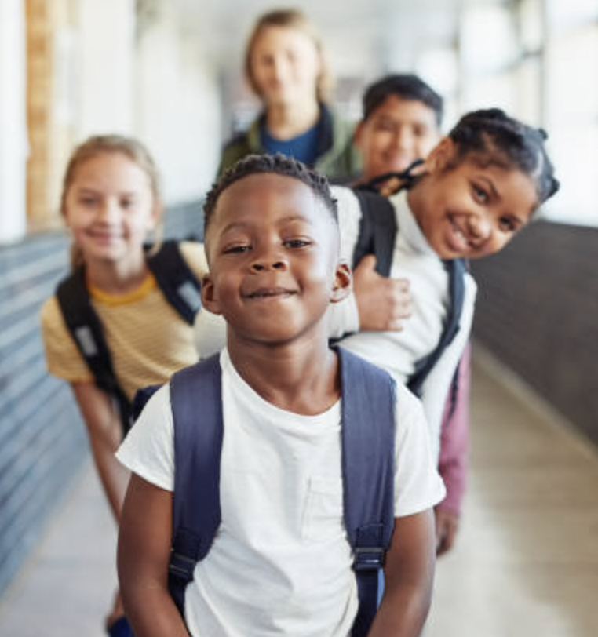

Introduction
The remarkable disruption of the COVID-19 pandemic stressed the educational system unlike ever before. In this period of pandemic recovery, there is an exceptional need to place greater emphasis on social and emotional well-being. Recent surveys and studies show increases in poor mental health and suicidal thoughts and behaviors in all age groups (CDC, New CDC data illuminate youth mental health threats during the COVID-19 pandemic, 2022). Practices known to combat these negative trends include promoting safe and supportive environments, as well as placing even greater emphasis on the need to cultivate and reinforce social and emotional well-being (CDC, What Works In Schools: Safe and Supportive School Environments, 2023; CDC, Adolescent and School Health, 2023).

Social Emotional Learning (SEL) is an integral part of child development in education. Acquiring skills, knowledge, and attitudes to manage emotions leads to the development of healthy identities. This enables children and later adults to achieve personal goals, elicit empathy for others, cultivate and sustain healthy relationships, and make caring, responsible decisions (Jones, 2015; Durlak J. W., 2011). Integrating programs with an SEL focus in PK-12th grade classrooms shows improved positive outcomes, including better test scores, higher graduation rates, and improved social behavior (Durlak J. W., 2011; Freya, 2005; Edwards, 2005).

The Collaborative for Academic, Social, and Emotional Learning (CASEL) details five core competencies of SEL: self-awareness, self-management, social awareness, relationship skills, and responsible decision-making (CASEL, "What is SEL?", 2017; Committee for Children, n.d.). SEL skills are primarily learned in the home, preschool, and school (Durlak J. A., 2011; Palmer, 2019). A state-based review of the impact of SEL curriculum found the best adoption occurs in preschool-age children (Palmer, 2019). This finding resulted in the adoption of instructional state standards for SEL in all but three states and territories. A handful of states have carried SEL standards into later grades with evidence to support effectiveness in research (National Conference of State Legislatures, 2018; Eccles, 1993; National Commission on Social, 2018).

SEL indicators are becoming increasingly important as states develop new accountability systems under the Every Student Succeeds Act (US Department of Education, 2015). Metrics may include school climate or engagement, which schools find valuable in a time of educational disruption as experienced in 2020-2021. The rise of SEL indicators is leading to the creation of new curricula available for preschool through 12th grade, whether in public or charter schools or other learning environments (CASEL, Evidence-Based Social and Emotional Learning Programs: CASEL Criteria Updates and Rationale, 2021).

The objectives of CASEL-oriented curricula include the following measured outcomes (CASEL, What Is the CASEL Framework?, 2023):
- Improvement in student social emotional skills, attitudes, relationships, academic performance, and perceptions of classroom and school climate;
- Long-term positive impact on academic performance;
- Decline in student anxiety, behavior problems, and substance abuse.

Bettertogether3 - better educators, better students, better communities
Bettertogether³ was designed and developed by an expert team of educational professionals with years of classroom teaching experience and school leadership and is grounded in evidence-based practices supported by the aforementioned research (bettertogether3, 2024).

Program Description & Framework

PreK-12 SEL Curriculum
Bettertogether³ is a PreK -12 responsive SEL program consisting of digital grade-banded lessons that support student SEL needs through developmentally appropriate practices that are differentiated by age group. Lessons are grounded in the 5 CASEL competencies and accompanying learning standards, including the newest priorities of Belonging, Emotional Safety, and Community Building. It is a fully integrative solution, available in both English and Spanish, that allows for a high level of teacher autonomy in meeting the needs of their students, whom they know best.

Assessments
The program includes a student pre- and post-assessment (with an optional mid-year assessment), providing data trends for each classroom to guide teachers in the most pressing need areas. All lessons are tailored to address three of the five CASEL competencies and “belonging and inclusion” including (CASEL, What Is the CASEL Framework?, 2023):

- Social-awareness
- Self-awareness
- Healthy relationship skills
- Self-management
- Responsible decision-making
- Belonging and inclusion*

*Bettertogether³ includes an additional competency of “belonging and inclusion” to address increasing trends of isolation and exclusion, experienced more often by females and LGBTQ+ students (CDC, 2023). Pre- and post-assessment questions all correspond with one of the six competencies used in the bettertogether³ curriculum.

Designed for the Busy Educator
Previous studies have found that SEL has both immediate benefits (e.g., positive attitudes toward self and others) and long-term benefits (e.g., positive behaviors, academic success, and mental health) for students in school and life after school (Mahoney, 2018). Developed by educators, this grade-banded curriculum offers explicit instruction for critical skills and strategies for improved SEL function. The curriculum is designed for integration into the school day, with educators using it in 15–30-minute segments, requiring minimal or no preparation. Lessons can be incorporated into instructional time, within any schedule, and do not require “SEL Class”. The interactive and connective lessons can be used immediately as a stand-alone lesson or integrated seamlessly into existing classroom schedules and school structures like Morning Meeting, Restorative Circles, Advisory, or content area instruction.

Lessons span technique areas to include student partner and group conversations, individual reflection time, movement and multi-sensory practice, and artistic expression. Each of the 80 grade-banded lessons are formatted in a simple step-by-step facilitation guide for the teacher. The lessons are organized into 10 areas of competency, each with 8 lessons to ensure meeting three of the five CASEL competencies with depth and rigor across the K-12 spectrum. The section are organized as follows:

Self-Management
- Emotion identification and regulation
- Mindfulness
- Self-care & self-compassion
Healthy Relationships
- Healthy relationships
- Communication
Responsible Decision-Making
- Resilience & problem-solving
- Moving through trauma
Belonging and Inclusion
- Trust
- Kindness & gratitude
- Empathy
Everything teachers need for instruction, including facilitation slides via Google when applicable, is provided for support.
Each activity-based lesson includes:
- The “purpose” and “payoff” — these terms refer to supporting information designed to prime teachers with background information and lesson outcomes before planning.
- Notes for any minimal preparation that might be needed prior to the lesson to ensure success.
- Step-by-step instructions for lesson delivery, including examples and conversation stems to support teachers’ pedagogy.
The core SEL curriculum increases equity in classrooms by allowing students to build strong relationships with peers and adults, ensuring all voices and perspectives are heard, and practicing the skills of social awareness, self-awareness, and self-management leading to an overall positive classroom culture. The SEL competencies practiced throughout the comprehensive curriculum truly help students become citizens of a global society. Lesson design allows for practice within the authentic context of their own classroom community.

In addition to encompassing a wide range of instructional methods to accommodate diverse learning styles, lessons are intentionally designed for students to embrace the identity, values, and perspectives of self and others. While differentiation supports are integrated into each core lesson to assist all learners, the bettertogether³ digital platform also provides a dedicated section with additional differentiated learning resources. These resources include visual supports, audio supports, and alternative activities designed to meet the needs of multilingual students or those requiring alternative opportunities for learning and practice.

Data-Driven Instruction
Constant change, uncertainty, and continued pressure to deliver positive student outcomes can leave teachers with decision fatigue. The bettertogether³ data collection tool ensures that schools can administer a simple, digital self-assessment survey to all students aligned to the 5 CASEL competencies (and additionally the category of Belonging and Inclusion). Student assessment data is used to measure SEL competency needs and growth when administered as a pre-and post-assessment each year, with the option to assess mid-year as well. The ability to analyze student baseline data allows for data-driven, responsive planning for each classroom and across grade levels.

Educator Wellness
New research suggests that it is important to recognize that teachers' capacity to support their students is influenced by teachers' own well-being (Hamilton, 2020; Oberle, 2016). Bettertogether³’s comprehensive programming specifically supports the growth of adult SEL through our digital wellness modules called Permission to Pause.

Grounded in Dr. Brené Brown’s research on vulnerability, trust, emotional literacy, resilience and connection, as well as Dr. Timothy Clark’s research on the 4 stages of psychological safety, these modules facilitate personal introspection and connective conversations for all staff members. Feeling a sense of belonging and being seen, heard, and valued is the cornerstone of a positive, inclusive school culture (Clark, 2020; Brown B. , 2018; Brown B. , 2021). This creates a shared language for adults and students that builds strong relationships and increases equity in classrooms and throughout buildings. Brown states that a shared language serves as our portal to meaning-making, connection, healing, learning, and self-awareness. Additionally, the ability to understand one’s own emotions and those of others, along with having the correct words to describe specific emotions, increases the ability to identify those emotions in others, as well as recognize and manage emotional experiences (Brown B. , 2021; Brown B. , 2018). Therefore, adult SEL capacity-building is critical to the systemic success of any student SEL curriculum implementation.

Consisting of 10 on-demand modules, “Permission to Pause” is designed to fit flexibly into a school and/or district’s current structures and priorities. For example, the modules can be utilized during district-wide professional development days, building staff meetings, or even grade level PLCs. Each module includes individual reflection time, partner work, and group conversation support. Educators are consistently building cultural competence and collective efficacy independently and with their teams. Educators with high efficacy show greater effort and persistence, a willingness to try new teaching approaches, set more challenging goals, and attend more closely to the needs of students who require extra assistance. In addition, when collective efficacy is present, staff members are better equipped to foster positive behavior in students and in raising students’ expectations of themselves by convincing them that they can do well in school. This is important because we know students’ model what they see from adults (Donohoo, 2017). With an emphasis on a continuous learning process for educators, cycles of practice and learning support the command of educator SEL competencies as they concurrently deliver SEL instruction in the classroom.

Professional Development

Introductory Workshop
Bettertogether³ (bt³) offers an initial workshop that sets teams up for an immediate launch of the SEL implementation. This session is designed to ensure that teams gain a basic understanding of program goals and the confidence to begin integrating the resources into their classrooms right away. During this session, bt³ coaches conduct an interactive walk-through of the digital platform. Participants are introduced to the student assessment tool, core student SEL lessons, educator wellness survey, and educator Permission to Pause modules.
Additional time is included in the session to:
- Plan for the delivery of initial lessons and use of resources.
- Model SEL strategies that can be immediately implemented in classrooms.
- Allow for faculty and staff to take the initial educator wellness survey and reflect on results.

Ongoing Professional Development and Coaching
After the initial introductory workshop, district leaders, building leaders, and teachers receive on-going support through building-based professional development sessions, a leadership learning series, and asynchronous resources/support in the educator platform. This multi-faceted training and responsive coaching approach offers support throughout the school year.
- On-going building-based training: bt³ offers flexible coaching sessions designed to support the continued learning of staff and leaders. Coaches are available to model lessons, engage leaders in classroom walkthroughs and procedural feedback, and lead PLCs with teachers to analyze student assessment data and implementation progress.
- Leadership Learning Series: bt³ has cultivated a unique coaching model just for building and district leaders, offering monthly virtual coaching sessions designed to tackle implementation challenges and support building-wide improvement goals, along with asynchronous leadership modules to support self-paced learning.
- Asynchronous Teacher Supports: all educators have access to digital modules designed to enhance adult SEL competencies. These modules support adult learners in areas such as emotional literacy, stress management, overcoming overwhelm, and fostering a sense of belonging and inclusion. They can be accessed at any time to meet the evolving needs of adults.

Implementing the Pilot Curriculum
Participating teachers underwent training on implementing the core curriculum and the educator wellness modules, which comprised three days of virtual and in-person professional development and support. Each session included SEL strategies for teacher well-being, along with experiences to familiarize themselves with the student lessons. Each session included time for creating an action plan of lessons they were equipped to use, engaging in collaborative discussion, sharing successes and receiving support for delving deeper into the design and utilization of bettertogether³. Teachers received a total of 8 hours of professional development. The building principal had access to a coach for ongoing questions and individual support via email and phone.

Educators received a sequencing guide as support when specific areas of student SEL needs were noticed, which provided suggested lessons to meet the need. Educators utilizing bettertogether³ were encouraged to consistently administer lessons and activities. They began the year with lessons focused on Building Psychological Safety and Creating a Classroom Culture of Belonging. School belonging is associated with a range of positive educational and developmental outcomes, including psychosocial health and well-being, prosocial behavior and academic achievement, and transition into adulthood. School belonging also positively contributes to a number of factors that promote student academic functioning, mental health, and well-being (Allen K. A.-B., 2018; Allen K. A., 2012; Arslan G. , 2021; Arslan G. A., 2020). Educators delivered approximately three lessons per week during their advisory period.

Supporting materials included an overview of lesson steps, any additional lesson supports, and facilitation tips. Everything teachers need for instruction, including facilitation slides via Google when applicable, was available on the digital learning platform.

Pilot Study

Purpose
Bettertogether³ core curriculum was piloted in schools in Florida, Minnesota, and Illinois beginning in the fall of 2020. Over the past 4 academic years, approximately 5500 students in 25 schools across the country have experienced bettertogether³ as their SEL curricular tool. As such, the designers have been able to implement, evaluate, and modify lessons, sequences, and professional learning to ensure the maximum effectiveness of the intervention. The curriculum and professional development support was approved by the Minnesota Department of Education as a viable program to use as a pilot in participating Minnesota districts.

The current pilot study is a quasi-experimental examination of the bettertogether³ SEL curriculum was intended to validate the use of bettertogether³ as an effective tool to grow student competency in the areas of student healthy relationship skills, self-management, and responsible decision-making and belonging and inclusion with a minimum of one semester of curriculum administration. Social awareness and self-awareness were not assessed as part of this pilot study. The goal of the study was to test the effectiveness of the bettertogether³ comprehensive programming on improving SEL competencies among students who received the curriculum.

Specifically, this study addressed four research questions:
- Did students who received the bettertogether³ SEL intervention improve their healthy relationship skills and understanding compared to students who did not receive the same intervention?
- Did students who who received the bettertogether³ SEL intervention improve their self-management skills and understanding compared to students who did not receive the same intervention?
- Did students who received the bettertogether³ SEL intervention improve their responsible decision-making skills and understanding compared to students who did not receive the same intervention?
- Did students who received the bettertogether³ SEL intervention improve their belonging and inclusion skills and understanding compared to students who did not receive the same intervention?

For each of the four aforementioned questions, the authors examined if the direction of the effect would favor the SEL intervention and if the changes in the outcomes between the baseline (start of the intervention) and the follow-up (five months post-baseline) differed between the intervention and control (non-intervention) groups.

Statistical Methods
SPSS® software was used to perform the statistical analyses of this evaluation. Descriptive statistics were used to evaluate the characteristics of each school and grade by intervention group and control group. Factor analysis was used to evaluate validity and reliability tests were assessed. An independent sample t-test was used to measure baseline equivalence between the student groups. Next, an analysis of covariance (ANCOVA) was used to measure the differences in adjusted group means using pre and post-test data collected from the intervention group and control group. Lastly, paired samples t-tests were used with the intervention group data to determine the extent and significance of change between the pre and post assessments. Missing data were treated as missing in SPSS. Students with greater than two missing responses for questions in either the pre- or post-tests were excluded from the analysis.

Classroom Selection and Assignment
The pilot school selected for this study is in the Columbia Heights School District is an urban-based, public school in metropolitan St. Paul/Minneapolis, MN serving approximately 700 students in grades 6-8 (U.S. News and World Reports, 2024). Diverse populations comprise 85% of students, with 79% receiving free or reduced lunch (Table 1). School A was intentionally selected as it is mid-sized, multi-grade, linguistically, and racially and ethnically diverse. School A is eligible for and provides Title 1 services. One school district, Columbia Heights Public Schools, is represented in this study.

Table 1. Racial and ethnic percent distribution and free and reduced lunch by school and study average
Race/Ethnicity/SES | School A %
Asian | 4
Black | 29
Hispanic | 42
Indigenous | 1
White | 16
Multi-Racial | 8
Other | 0
Free Reduced Lunch or Low SES | 79

Classrooms from School A in Columbia Heights School District were recruited for participation in this quasi-experimental study. Ten classrooms were identified for inclusion and were randomly assigned to either the intervention group or the control group. The bettertogether³ curriculum was administered to students in the intervention group over the 2022-2023 school year. The control group did not receive the curriculum instruction provided to the intervention group.

School administrator participation commitments included supporting teachers with time and resources, as well as obtaining parental consent and assent for students to complete the pre- and post-test assessments.

After Columbia Heights School District random assignment of classrooms to the intervention or control group, a total of 118 students in grades 6-8 were participating from one school. Five classroom teachers administered the curriculum (i.e., grade-banded instruction, self-assessments, professional development (teachers), and coaching (teachers)), and the other five classes were assigned to the control group (i.e., only self-assessments).

One student from the intervention group and two from the control group did not have a complete pretest and were excluded from the analysis, resulting in 55 students in the intervention group and 60 in the control group.

To assess potential selection bias and ensure comparability of the intervention and control groups, and assess the possibility that those selected do not systematically differ from those who did not participate, a baseline study was conducted prior to the intervention (OECD, 2010).

There were an average of 9.1 students in each intervention classroom and 12 in each control group classroom. There were two intervention group classrooms in 6th grade and three in 8th grade, while the control group had one classroom in 6th grade and four in 7th grade (Table 2). Given the overlap of teachers and courses taught to students multiple grades, underlying differences between grade levels was not evaluated as part of this pilot. Distribution of students by race was similar between the intervention and control groups with the difference lacking statistical significance (Table 3).

Table 2. Student distribution by grade and group
 |  | Classroom Count by Grade
 | Total Students | 6th | 7th | 8th | Total Classrooms
Intervention Group | 55 | 2 |  | 3 | 5
Control Group | 60 | 1 | 4 |  | 5

Table 3. Student distribution by race and group
 |  | Group
 |  | Intervention | Control | Total
Race | American Indian or Alaska Native | 1 | 1 | 2
 | Asian | 3 | 0 | 3
 | Black or African American | 16 | 12 | 28
 | Black-African American | 1 | 0 | 1
 | Black, Not Hispanic | 1 | 0 | 1
 | Hispanic | 18 | 33 | 51
 | Two or More | 4 | 6 | 10
 | White | 11 | 8 | 19
 | Total | 55 | 60 | 115
p = 0.154

Measures
Pre- and post-assessment questions fit within the three competencies used in the bettertogether³ curriculum which are healthy relationship skills, self-management, and responsible decision-making. Belonging and inclusion comprised a fourth competency. These competencies directly align to the inter and intra personal CASEL competencies of relationship skills, self-management and responsible decision-making (CASEL, What Is the CASEL Framework?, 2023). The intervention group and control group completed a pre-assessment in the fall (November 2022) and a post-assessment in spring (March 2023) after the curriculum was used consistently and strategically using data to guide lesson choices. Assessments were self-reported by students. Follow-ups were not conducted after the conclusion of the pilot study.

In the pre- and post-assessments, students indicated the extent to which they agreed with statements using a four-point likert behavioral rating scale ranging from 1 (“This is hard for me.”) to 4 (“I am really good at this.”). A sample item is “I am able to tell someone how I am feeling”. Response scores for the 13 questions were averaged with higher scores indicating improvement in the SEL constructs measured (α = 0.324, α = 0.252 at pre-test and post-test, respectively).

Student grade levels and instructors were identified in the survey but were coded to protect student identity. Student pre- and post-assessments were matched using a numeric student ID. Students indicated their belief regarding a particular SEL statement using the scale noted in Figure 1, subsequently coded 1-4 for analytic purposes.

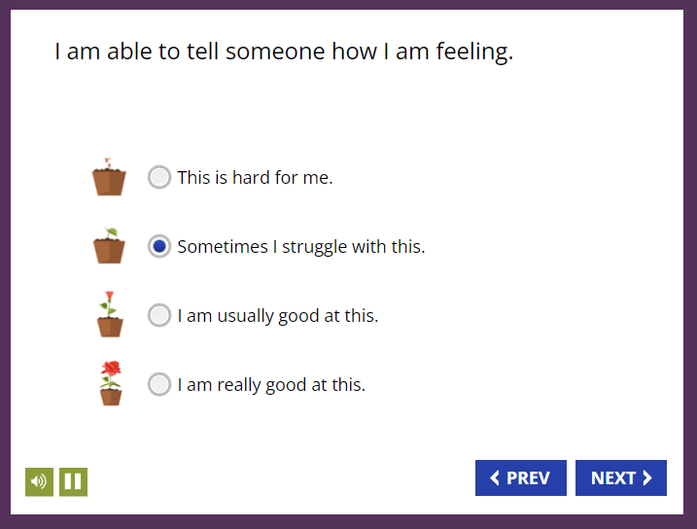
Figure 1. Student assessments

The assessment tool provided students the option to listen to the questions and possible responses. There was no time limit for completing the assessment, and visual supports were available for diverse learners (example above). A list of all questions included in the assessment is available in Appendix A.

The pre-assessment survey allowed for data-driven decision-making by providing teachers reports of class trends aligned to the CASEL competencies, opportunities for growth, and priority areas for intervention. Teachers used real-time data reports linked to recommended focus lesson sequences in order to foster the necessary skill development.

Validity
Internal validity of the constructs that underlie performance (i.e., scores) on the assessment were examined using factor analysis (Miami, 2020; J. Cox, 2019). The analysis consisted of nine questions representing four components - belonging and inclusion, responsible decision-making, self-management, and healthy relationship skills. For the principal axis factor analysis with varimax rotation, four factors were requested with the first factor accounting for 21.2% of variance, 15.6%, 15%, and 3.1% for factors 2-4 respectively. Table 4 displays the items and factor loadings for the rotated factors. Factors with loadings < .4 were omitted.

The first factor, which seemed to index responsible decision-making and self-management, had strong loadings. The second factor appeared to index belonging and inclusion though with similar results for factor three along with nearly equivalent variance. The fourth factor seemed to index only responsible decision-making, and when the analysis was repeated with three factors belonging and inclusion better comprised the second index with healthy relationship skills comprising the third. While these results do not support exacting separation of the four components in subsequent analyses, the presence of each factor’s strength exceeding .4 provides support for validity (Leech, 2015).

In addition, all nine items correlated at least .3 with at least one other item suggesting favorable factorability. The Kaiser-Meyer-Olkin measure of sampling adequacy was .87, above the recommended value of .6, and Bartlett’s test of sphericity was significant (X²(36) = 346.7, p < .001). The diagonals of the anti-image correlation matrix were all over .5 supporting the inclusion of each item in the factor analysis. The communalities were all above .3 confirming that each item shared some common variance with other items (Leech, 2015).

Table 4. Rotated factor matrix
 | Factor
 | 1 | 2 | 3 | 4
RDM: I have and USE strategies to recover from upsetting/uncomfortable emotions quickly. | .741 |  |  | .415
SEM: I recognize and USE strategies to manage my stress before it becomes too much for me. | .707
SEM: I am able to calm myself when I am worried, lonely, anxious, or angry. | .660
RDM: When I have a problem or a conflict, I ask others I trust for help. | .428
BEI: I feel a sense of connection and belonging at my school. |  | .877
BEI: I feel seen, heard and valued by at least one adult in the building. |  |  | .573
HRS: I am able to disagree with others without starting an argument. |  |  | .570
HRS: I work well with others. |  | .472 | .499
BEI: I am accepted by people who are different than I am. |  |  | .435
Extraction Method: Principal Axis Factoring.
Rotation Method: Varimax with Kaiser Normalization.
Rotation converged in 5 iterations.

Reliability
In this study, the reliability of the scale used in the assessment instrument was evaluated using the test/re-test method with the non-control group study. Reliability of scales for pre- and post-test were slightly higher than the range found by CORE researchers at .77 and .89, though the researchers state reliability is higher at older grade levels (H. Gellbach, 2018). Nunnally and others cite a Cronbach’s Alpha ≥ .7 as a conventionally acceptable reliability criterion (J. Cox, 2019; Nunnally, 1978; Miami, 2020). The reliability measured by Cronbach’s Alpha (α) demonstrates consistent measurement for all nine questions in the assessment for the pre- and post-tests (Table 5) .

Table 5. Cronbach’s Alpha by assessment question
 | Cronbach's Alpha/Pre | Cronbach's Alpha/Post
1_SEM I am able to calm myself when I am worried, lonely, anxious, or angry. | .908 | .929
1_HRS I am able to disagree with others without starting an argument. | .909 | .930
1_BEI I am accepted by people who are different than I am. | .906 | .930
1_BEI I feel a sense of connection and belonging at my school. | .904 | .930
1_BEI I feel seen, heard and valued by at least one adult in the building. | .907 | .932
1_RDM I have and USE strategies to recover from upsetting/uncomfortable emotions quickly. | .903 | .928
1_SEM I recognize and USE strategies to manage my stress before it becomes too much for me. | .907 | .932
1_HRS I work well with others. | .908 | .936
1_RDM When I have a problem or a conflict, I ask others I trust for help. | .916 | .940

Results
An ANCOVA was selected as one of four ideal methods for evaluating pre and post-test analyses (Vickers, 2001; Morgan, 2019; Leech, 2015). This approach helps control for pre-existing differences on the post-test by using a pre-test as a covariate to increase precision. For this pilot, an ANCOVA was used to assess whether the intervention group experienced higher growth in four SEL components between pre and post assessments compared to a control group. Baseline equivalency testing showed homogeneity of variance between the intervention and control groups (t₁₁₃=1.995, p = .751). Positive changes in mean responses for pre-tests and post-tests between the intervention and control groups were evident for all SEL categories included in the research question areas of foci, though much more substantially for the intervention group (Figure 2). Students in the intervention group demonstrated statistically significant improvements in SEL competency to the control group (F(1,991) = 12.1, p < .001.

Additional testing was performed for the same four SEL categories between the pre- and post-test for the intervention group (Figure 2, Table 6). For self-management (SEM), a paired sample t test indicated that the average post-test score was significantly higher than the pre-test, t (106) = 3.1, p = .003, d = .15. Similar results were experienced for belonging & inclusion (BEI), t (160) = 4.3, p < .001, d = .15, responsible decision-making (RDM), t (104) = 2.8, p = .006, d = .12, and healthy relationship skills (HRS), t (107) = 3.5, p < .001, d = .13 (Table 6, Table 7).

Table 6. Means, STD, and Error of the intervention group between the pre and post tests
Component |  | Mean | N | Std. Deviation | Std. Error Mean
Belonging and Inclusion | Q1 | 2.66 | 161 | 0.908 | 0.072
 | Q2 | 2.97 | 161 | 0.897 | 0.071
Responsible Decision-Making | Q1 | 2.65 | 105 | 0.940 | 0.092
 | Q2 | 2.90 | 105 | 0.990 | 0.097
Self-Management | Q1 | 2.59 | 107 | 0.990 | 0.096
 | Q2 | 2.89 | 107 | 0.904 | 0.087
Healthy Relationship Skills | Q1 | 2.85 | 108 | 0.905 | 0.087
 | Q2 | 3.11 | 108 | 0.801 | 0.077

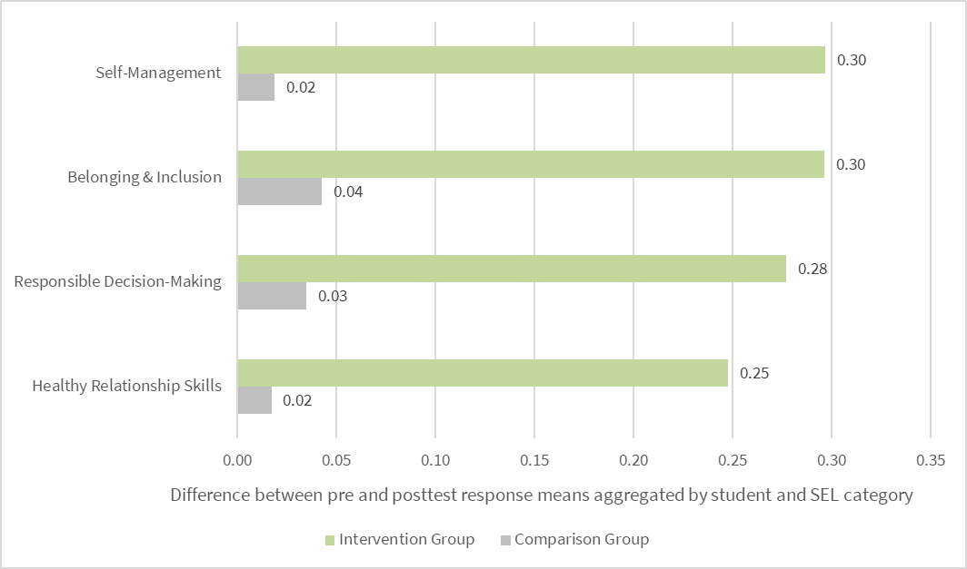Figure 2. Average change of responses between the pre-test and post-test of the intervention group and the control group

 | Mean Diff | Std. Deviation | Std. Error Mean | p-value
BEI | 0.30 | 0.90 | 0.07 | < .001
SEM | 0.30 | 1.01 | 0.10 | 0.001
RDM | 0.25 | 0.90 | 0.09 | 0.003
HRS | 0.26 | 0.77 | 0.07 | < .001
Table 7. Mean difference (Post-Pre), standard deviation, standard error mean, and p-value

Significance of the Findings
The pre- and post-test results were examined multiple ways, between groups and within groups, to assess whether the bettertogether³ curriculum resulted in positive change in six SEL categories of evaluation. The mean response for students in the intervention group and control group for the pre- and post-tests indicated statistically significant differences between the group responses, with the students in the intervention group reporting statistically significant improvements in all four SEL competencies evaluated.

In sum, there is clear evidence that students who completed the bettertogether³ curriculum improved their abilities in self-management, belonging and inclusion, responsible decision-making, and healthy relationship skills when assessed at baseline and after completing the curriculum, as well as when compared to students who do not complete the curriculum. Additional evaluation may show positive improvements in the remaining two areas of Self-Awareness and Social Awareness.

Self-Management
Self-management, known as self-control or self-regulation, measures one’s ability to regulate emotions, thoughts, and behaviors in different contexts in order to make decisions and reach goals that benefit oneself and others. This encompasses managing stress, delaying gratification, self- motivation, and setting both personal and academic goals (CASEL, Safe and sound: An educational leader's guide to evidence-based social and emotional learning programs—Illinois edition, 2005).
Students who have skills and strategies for self-management are more successful in the areas of self-motivation, self-reliance, and the independence needed to know their well-being is in their control. The research underlying the effectiveness of self-management suggests this competency is key in improving both academic and behavioral outcomes (Briesch, 2009; Mooney, 2005). Regarding academic outcomes, self-management has been shown to improve academic performance and rates of work completion and accuracy (Carr, 2014; Smith, 2022; Mooney, 2005). With regard to behavioral outcomes, studies suggest self-management may be used to improve attention and compliance (e.g., following directions), and reduce impulsivity and externalizing behaviors (e.g., talking out, out of seat).

With teachers reporting a significant increase in disruptive or disengaged behaviors being displayed by a greater number of students than prior to the pandemic, there is a case to be made that the growth in the competency of self-management may be critical in academic success. In addition, having self-motivation, self-reliance, and an overall sense of control and independence can only benefit in the area of confidence and self-acceptance, which in turn, allows for students to thrive (Briesch, 2009; Carr, 2014; Mooney, 2005; Smith, 2022).

The findings of this quasi-experimental study evidence improvement in self-management among the intervention group as shown by statistically significant, positive change (Table 7). This outcome was measured by the difference in mean scores for the questions aligned to self-management before and after completion of the curriculum. Not only did the intervention group experience a significant increase in the ability to self-manage, the growth of the intervention group significantly outpaced the growth of the control group (Figure 2). This acceleration in competency growth can be attributed to implementation of the curriculum as the sole variable to intervention.

Belonging and Inclusion
Similar to the outcomes for self-management, the study confirms positive change in feelings of belonging and inclusion with the implementation of the bettertogether³ curriculum. Growth measured by the mean difference of pre- and post-tests, as well as between the intervention group and control group were statistically significant supporting that students achieve stronger feelings of belonging and inclusion as a result of bettertogether³ curriculum.

Healthy classroom climate reflects supportive teacher-student relationships, effective classroom management, and student connectedness to school, which are further associated with positive student outcomes, both academic and social-emotional (Elbertson, 2009; Oberle, 2016; Jennings, 2009). Students who don’t feel a sense of belonging often struggle to focus cognitively and find it difficult to give attention to tasks. In addition, they can experience issues with emotional wellness if they do not feel as though they have a friend that they can trust to share their feelings. These feelings could manifest in frequent visits to the nurse’s office, disruptive behavior, isolation, or even truancy, as students look for a way to avoid environments where they feel as though they don’t belong.
On the other hand, there is an argument to be made that students who are members of a classroom culture where belonging is nurtured by exploring identity, honoring uniqueness, creating opportunities to share who they are and to truly be seen, heard, and valued experience a stability and acceptance that sets them up to thrive. The social aspect of the classroom environment contributes significantly to student learning. When students experience warm, supportive, and respectful interactions with their teachers, they tend to display academic motivation and engagement (Elbertson, 2009).
This pilot study showed improvement in belonging and inclusion with a mean difference between pre- and post-tests tied with self-management for the highest measurable change and strongly significant (Table 7).This outcome was confirmed with an increase among the students receiving the intervention outperforming those who did not.

Responsible Decision-Making
As with the competencies of self-management and belonging and inclusion, the third largest category of growth was responsible decision-making. Student assessments supported statistically significant positive change between pre- and post-test and when evaluated against mean scores of the control group.
According to CASEL, responsible decision-making is the ability to make caring and constructive choices about personal behavior and social interactions across diverse situations. This includes the capacity to consider ethical standards and safety concerns, and to evaluate the benefits and consequences of various actions for personal, social, and collective well-being.
Developing responsible decision-making skills in students and adults is integral to acting responsibly across diverse settings to foster personal and collective well-being. Young people develop the capacity “to engage in initiatives and to co-create structures and processes that are inclusive, equitable, and mutually supportive” (Jagers, 2018).
When students have strong responsible decision-making skills, they are more apt to display open mindedness and exhibit curiosity about situations and people rather than jump to immediate conclusions. In addition, when responsible decision-making skills are developed, students have the ability to analyze a situation before making a decision, as well as evaluate the consequences of a particular choice they may make. This area of skill development is important as it requires a consideration of how individual actions affect their well-being, the well-being of others, and the impact it will have on others. It is a skill that is the foundation for developing responsible global citizens who are empathetic, open to different perspectives, and understand the interconnectedness of their actions on the larger community.
Responsible decision-making skills were strengthened among intervention group students participating in this pilot as well as compared to control group students. The change from pre- to post-test was evident and statistically significant (Figure 2, Table 7).

Healthy Relationship Skills
The final category to demonstrate statistically significant growth was healthy relationship skills. Students in the intervention group evidenced improvements in this category after completing the curriculum and when evaluated against the control group.

Broadly, healthy relationships are ones where adolescents can safely feel and express respect for themselves and others. This comes from mutual trust, honesty, good communication, being understanding and calm during arguments, and consent. Peers play a particularly big role in creating an identity during adolescence (Wildsmith, 2013).
When students feel connected to others in school, they are more likely to have better attendance, higher grades, and remain in school. When a student feels emotionally supported, they are more likely to show perseverance and exert extra effort when concepts become difficult for them to learn. When healthy relationships are present in a classroom setting, students are more willing to show up with a positive attitude.
Students who feel connected to others in school are less likely to engage in risky behavior. A study of students in grades 6 to 8 also showed that school connectedness was significantly related to a measure of increased problem behavior including involvement in vandalism, fighting, and weapon carrying, as well as alcohol use and substance use (Simons-Morton B, 1999). These students are also less likely to experience emotional problems.
Unsurprisingly, students in this pilot study showed improvement in healthy relationship skills in comparing pre- and post-tests. While the change was only slightly lower than the other competencies, the difference was statistically significant.

Conclusion and Recommendations
The 6-8th grade students from Columbia Heights School District who received the bettertogether³ SEL intervention significantly improved their self-management, skills in building healthy relationships, responsible decision-making skills, and sense of belonging in the school community compared to those students who did not receive the same intervention. Given the significant findings in the middle school in Columbia Heights, MN, the following recommendations are made to the district:
- A school-wide adoption of the bettertogether³ program to transform the culture and create a shared language, common strategies, and an aligned implementation plan. There is extensive research available on the benefits of school-wide implementations as a key factor in a successful and sustainable SEL implementation (Durlak J. W., 2011; Jones, 2015; Weare, 1999; Weissberg, 2023; Lendrum, 2013)
- Given CASEL’s priority to “Design Opportunities for Adults to Connect, Heal, and Cultivate Their Own SEL Competencies”, consistent use of the bettertogether³ wellness modules for professional development to allow maximum time for adult connection, healing, and engagement. Teacher emotional intelligence has a significant impact on the teaching and learning process, and teacher emotional intelligence has been shown to influence student learning behaviors, engagement, and academic performance (Corcoran R. P., 2013). When adults thrive, students can thrive.
- The addition of leadership development coaching for administrators and ongoing professional development for teachers in service of continuous improvement of SEL and overall culture. A new implementation can bring feelings of incompetence, uncertainty, and a desire to return to what is known and comfortable. Not only are classroom instructional practices and routines new, but also leaders in the building whose role is to support teachers are new to the role of monitoring and supporting fidelity and feeling equally uncomfortable and unsure.
Since implementation is a process that occurs over time, and stages of implementation require thinking through the right activities for each stage to increase the likelihood of success, participating in leadership development coaching can support the successful movement through the stages of implementation which are exploration, installation, initial implementation and full implementation (Felner, 1993; Fixsen, 2007).

Appendix A

Pre- and Post-Assessment Questions
I am able to calm myself when I am worried, lonely, anxious, or angry.
I am able to disagree with others without starting an argument.
I am accepted by people who are different than I am.
I can describe how I am feeling to another person.
I can get along with people who have different perspectives/ideas than I do.
I can recognize how others are feeling and can respond with appropriate reactions when they are upset.
I can recognize when I am stressed or worried.
I feel a sense of connection and belonging at my school.
I feel seen, heard and valued by at least one adult in the building.
I have and USE strategies to recover from upsetting/uncomfortable emotions quickly.
I recognize and USE strategies to manage my stress before it becomes too much for me.
I work well with others.
When I have a problem or a conflict, I ask others I trust for help.

References
Allen, K. A. (2012). Belonging as a guiding principle in the education of adolescents. . Australian Journal of Educational & Developmental Psychology, 108-119.
Allen, K. A.-B. (2018). What schools need to know about fostering school belonging: A meta-Analysis. Educational Psychology Review, 1-34.
Arslan, G. (2021). School bullying and youth internalizing and externalizing behaviors: Do school belonging and school achievement matter? . International Journal of Mental Health and Addiction.
Arslan, G. A. (2020). Exploring the Impacts of School Belonging on Youth Wellbeing and Mental Health: A Longitudinal Study. Child Indicators Research.
bettertogether3. (2024). Retrieved from https://bettertogethercubed.com/
Blase, K. &. (2014). Implementation Science: Changing Hearts, Minds, Behavior, and Systems to Improve. Educational Outcomes.
Briesch, A. M. (2009). Review and analysis of literature on self‐management interventions to promote appropriate classroom behaviors (1988–2008). School Psychology Quarterly, 106–118.
Brown, B. (2018). Dare to Lead : Brave Work. Tough Conversations. Whole Hearts. Random House.
Brown, B. (2021). Atlas of the Heart: Mapping Meaningful Connection and the Language of Human Experience. . Random House Publishing Group.
Carr, M. E. (2014). Self‐management interventions on students with autism: A meta‐analysis of single‐subject research. Exceptional Children, 22-44.
CASEL. (2005). Retrieved from Safe and sound: An educational leader's guide to evidence-based social and emotional learning programs—Illinois edition: https://casel.org/safe-and-sound-guide-to-sel-programs/
CASEL. (2017). "What is SEL?". Retrieved from Center for Academic, Social, and Emotional Learning.: https://casel.org/what-is-sel/
CASEL. (2021, 01 11). Evidence-Based Social and Emotional Learning Programs: CASEL Criteria Updates and Rationale. Retrieved from https://casel.org/wp-content/uploads/2021/01/11_CASEL-Program-Criteria-Rationale.pdf
CASEL. (2023). What Is the CASEL Framework? Retrieved from https://casel.org/fundamentals-of-sel/what-is-the-casel-framework/
CDC. (2022, March 31). New CDC data illuminate youth mental health threats during the COVID-19 pandemic. Retrieved from https://www.cdc.gov/media/releases/2022/p0331-youth-mental-health-covid-19.html
CDC. (2023, April). Adolescent and School Health. Retrieved from https://www.cdc.gov/healthyyouth/data/yrbs/yrbs_data_summary_and_trends.htm
CDC. (2023, March 13). What Works In Schools: Safe and Supportive School Environments. Retrieved from https://www.cdc.gov/healthyyouth/whatworks/what-works-safe-and-supportive-environments.htm
Clark, T. (. (2020). The 4 Stages of Psychological Safety (1st ed.). Perlego. Retrieved from https://www.perlego.com/book/1352131/the-4-stages-of-psychological-safety-defining-the-path-to-inclusion-and-innovation-pdf
Committee for Children, e. a. (n.d.). Retrieved from What is Social-Emotional Learning?: https://www.cfchildren.org/what-is-social-emotional-learning/
Corcoran R. P., T. R. (2013). Does emotional intelligence predict student teachers' performance? . Teach. Teach. Educ., 34-42. Retrieved from doi: 10.1016/j.tate.2013.04.008
Donohoo, J. (2017). Collective Teacher Efficacy: The Effect Size Research and Six Enabling Conditions. The Learning Exchange.
Durlak JA, W. R. (2011). The impact of enhancing students’ social and emotional learning: A meta-analysis of school-based universal interventions. Child Development, 82(1), 405–432.
Durlak, J. A. (2011). Advancing the science and practice of social and emotional learning: Looking back and moving forward. . Review of Research in Education, , 40(1), 644–681 .
Durlak, J. W. (2011). The Impact of Enhancing Students' Social and Emotional Learning: A Meta-Analysis of School-Based Universal Interventions. Child Development, 405-432.
Eccles, J. e. (1993). Development during adolescence: The impact of stage-environment fit on. American Psychologist, 90-101.
Edwards, D. H. (2005). Acceptability and Student Outcomes. The Journal of Primary Prevention of a Violence Prevention Curriculum.
Elbertson, N. A. (2009). School-Based Social and Emotional Learning (SEL) Programming: Current Perspectives. In A. L. A. Hargreaves, Second International Handbook of Educational.
Felner, R. (1993). Restructuring the ecology of the school as an approach to prevention during school transitions: Longitudinal follow-ups and extensions of the School Transitional Environment Project (STEP). Prevention in Human Services.
Fixsen, D. B. (2007). Implementation: The Missing Link Between Research and Practice. APSAC Advisor.
Flumerfelt, S. &. (2013). Using Lean in the flipped classroom for at risk students. Educational Technology & Society, 356–366. Retrieved from http://www.ifets.info/journals/16_1/31.pdf
Freya, K. (2005). Effects of a school-based social–emotional competence program:. Applied Developmental Psychology.
H. Gellbach, H. H. (2018). Measuring Social Emotional Learning through Student Surveys in the CORE Districts. Retrieved from https://files.eric.ed.gov/fulltext/ED591082.pdf
Hamilton, L. &. (2020). Supports for Social and Emotional Learning in American Schools and Classrooms: Findings from the American Teacher Panel. Retrieved from https://www.rand.org/pubs/research_reports/RRA397-1.html
J. Cox, B. F. (2019). A review of instruments for measuring social and emotional learning skills among secondary students. Retrieved from https://ies.ed.gov/ncee/edlabs/regions/northeast/pdf/REL_2020010.pdf
Jagers, R. D.-D. (2018). Equity & Social and Emotional Learning: A Cultural Analysis. Retrieved from https://measuringsel.casel.org/wp-content/uploads/2018/11/Frameworks-Equity.pdf
Jennings, P. G. (2009). The Prosocial Classroom: Teacher Social and Emotional Competence in Relation to Student and Classroom Outcomes. Sage Journals.
Jones, D. G. (2015). Early Social-Emotional Functioning and Public Health: The Relationship Between Kindergarten Social Competence and Future Wellness. American Journal of Public Health.
Leech, N. B. (2015). IBM SPSS for Intermediate Statistics. Routledge.
Lendrum, A. H. (2013). Social and emotional aspects of learning (SEAL) for secondary schools: implementation difficulties and their implications for school-based mental health promotion. Child and Adolescent Mental Health.
Mahoney, J. L. (2018). An update on social and emotional learning outcome research. Phi Delta Kappan, 18-23.
Miami, U. o. (2020). STATS-U. Retrieved from How do we assess reliabilty and validity?: https://sites.education.miami.edu/statsu/2020/09/27/how-do-we-assess-reliability-and-validity/
Mooney, P. ,. (2005). A review of self‐management interventions targeting academic outcomes for students with emotional and behavioral disorders. Journal of Behavioral Education, 203-221.
Morgan, G. B. (2019). IBM SPSS for Introductory Statistics. Routledge.
National Commission on Social, E. a. (2018). Retrieved from The Practice Base for How We Learn: https://www.aspeninstitute.org/publications/practice-base-learn-supporting-students-social-emotional-academic-development/
National Conference of State Legislatures, e. a. (2018). National Conference of State Legislatures. Retrieved from https://www.ncsl.org/research/education/building-social-and-emotional-skills-in-afterschool-programs-a-literature-review.aspx
Nunnally, J. (1978). An Overview of Psychological Measurement. Springer.
Oberle, E. S.-R. (2016). Stress contagion in the classroom? The link between classroom teacher burnout and morning cortisol in elementary school students. Social Science Medicine.
OECD. (2010). Quality Standards for Development Evaluation. OECD. Retrieved from https://www.oecd-ilibrary.org/development/dac-quality-standards-for-development-evaluation_9789264083905-en
Palmer, J. (2019). Retrieved from Social and Emotional Development in Early Learning Settings: https://www.ncsl.org/research/human-services/social-and-emotional-development-in-early-learning-settings.aspx
Schmoker, M. (2006). Results now: How we can achieve unprecedented improvements in teaching and learning. Retrieved from https://eric.ed.gov/?id=ED494304
Simons-Morton B, C. A. (1999). Psychosocial, school, and parent factors associated with recent smoking among early-adolescent boys and girls. Preventive Medicine, 138-148. Retrieved from doi: 10.1006/pmed.1998.0404
Smith, T. T. (2022). Self‐management interventions for reducing challenging behaviors among school‐age students: A systematic review. Campbell Systematic Review.
Sparks, S. (2021). Education Week. Retrieved from Data: What we know about student mental health and the pandemic: https://www.edweek.org/leadership/data-what-we-know-about-student-mental-health-and-the-pandemic/2021/03
Stringer, K. (2019). “LA School Report.” To Build Emotional Intelligence in Students, Start with the Adults. SEL Pioneer Marc Brackett Helps Schools Do Both in 'Permission to Feel'. Retrieved from http://laschoolreport.com/to-build-emotional-intelligence-in-students-start-with-the-adults-sel-pioneer-marc-brackett-helps-schools-do-both-in-permission-to-feel/
U.S. News and World Reports, e. a. (2024). Retrieved from https://www.usnews.com/education/k12/minnesota/districts/columbia-heights-public-school-dist-106535
US Department of Education, e. a. (2015). Retrieved from Every Student Succeeds Act (ESSA): https://www.ed.gov/essa?src=ft
Vickers, A. A. (2001). Statistics notes: Analysing controlled trials with baseline and follow up measurements. British Medical Journal.
Wallace, A. R. (2018). Retrieved from Addressing Social and Emotional Needs During COVID-19: Emerging Themes in School Reopening Guides: https://www.ncsl.org/research/education/covid-19-addressing-social-and-emotional-needs-for-reopening-schools.aspx
Weare, K. (1999). Promoting Mental, Emotional and Social Health. Taylor & Francis Group.
Weissberg, R. D. (2023). Social and emotional learning: Past, present, and future. APA PsychNet.
Wildsmith, E. B. (2013). Dating and sexual relationships. Child Trends. Retrieved from https://www.childtrends.org/publications/dating-and-sexual-relationships

